An ISO 9001:2015 Certified

**RAPTI ENGINEERING COLLEGE**

(Affiliated to Pokhara University)

**Ghorahi Sub-Metropolitan-16 Saniambapur, Sarra Dang**

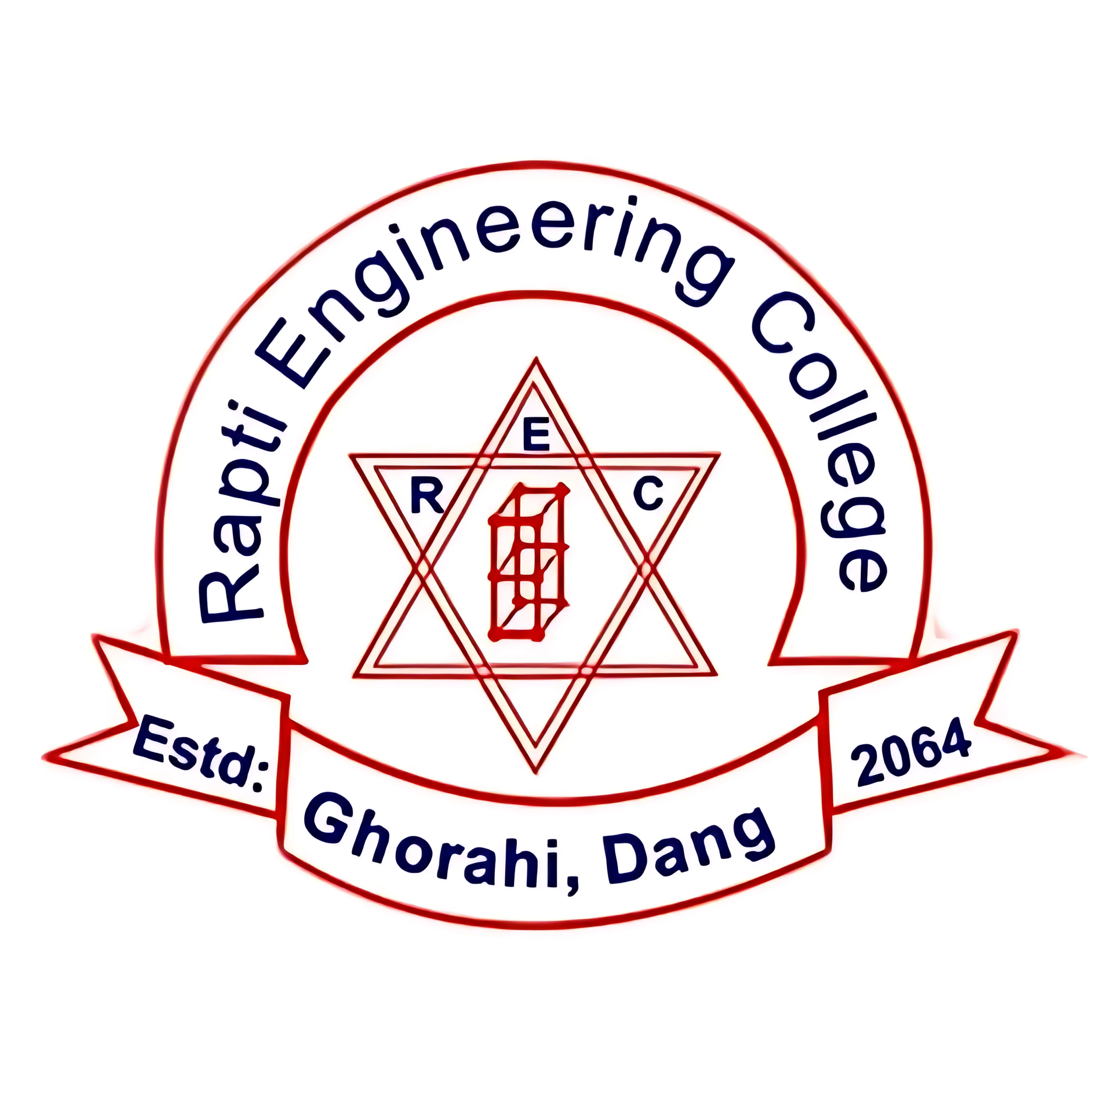

REPORT

ON

**“WebDev : Crafting Websites That Build Your Business”**

Submitted By:

Santosh Poudel

Submitted To:

Rapti Engineering College